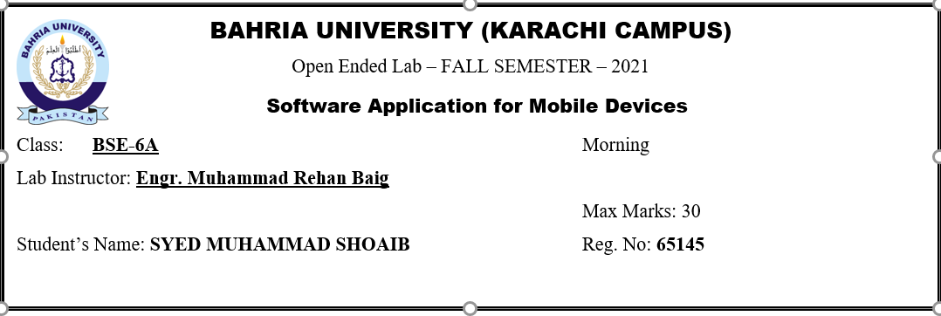

**Scenario**

**BSmart is a Company that make Smart Vehicles and Smart Home Appliances. BSmart is launching a mobile application that will control these products.**

**As a Software Engineer working in BSmart you are responsible for DESIGNING and implementing the following requirements and pages given below.**

**The Application contains following Pages and Requirements for the BSmart V1 Application.**

**Requirements and Pages**

**• Login/Signup page**

**User can Register/Authenticate from this page**

**• Smart CCTV surveillance Page.**

**This page shows the screening of all the connected cameras in the application.**

**• All Appliances Rooms Page.**

**This page shows the List of Rooms and launches that contains Smart Appliances like Smart Led, Smart Fan, Smart AC etc. that are controllable by Mobile Application.**

**User can Turn Led On/Off, AC On/Off using Mobile Application User can use speech recognition for automated controlling of Appliances using Mobile Application.**

**• Smart Garage Page From this page User can open or close garage door using mobile application**

**• Smart Car Page From this page User can give ignition, turn on the AC, even user can park the car using mobile application.**

**Every point is important. Read the given scenario carefully to perform this Open-Ended Lab.**

**MAIN CODE:**

**SIGNUP**

**XML**

<?xml version="1.0" encoding="utf-8"?>

<androidx.constraintlayout.widget.ConstraintLayout xmlns:android="http://schemas.android.com/apk/res/android"

xmlns:app="http://schemas.android.com/apk/res-auto"

xmlns:tools="http://schemas.android.com/tools"

android:layout_width="match_parent"

android:layout_height="match_parent"

tools:context=".Signup">

<LinearLayout

android:layout_width="match_parent"

android:layout_height="match_parent"

android:orientation="vertical"

android:gravity="center"

tools:context=".login">

<EditText

android:id="@+id/email"

android:layout_width="match_parent"

android:layout_height="wrap_content"

android:layout_marginRight="4pt"

android:layout_marginLeft="4pt"

android:layout_marginTop="10pt"

android:hint="Username"/>

<EditText

android:id="@+id/password"

android:layout_width="match_parent"

android:layout_height="wrap_content"

android:layout_marginTop="10pt"

android:layout_marginLeft="4pt"

android:layout_marginRight="4pt"

android:inputType="textPassword"

android:hint="Password"/>

<Button

android:id="@+id/btn_signup"

android:layout_width="match_parent"

android:layout_height="wrap_content"

android:layout_marginRight="4pt"

android:layout_marginLeft="4pt"

android:layout_marginTop="10pt"

android:text="SIGN UP"/>

<Button

android:id="@+id/btn_login"

android:layout_width="match_parent"

android:layout_height="wrap_content"

android:layout_marginRight="4pt"

android:layout_marginLeft="4pt"

android:layout_marginTop="10pt"

android:text="LOG IN"/>

</LinearLayout>

</androidx.constraintlayout.widget.ConstraintLayout>

**JAVA**

package com.example.samdoelmid;

import androidx.appcompat.app.AppCompatActivity;

import android.content.Intent;

import android.os.Bundle;

import android.view.View;

import android.widget.Button;

import android.widget.EditText;

import android.os.Bundle;

import android.widget.Toast;

import android.content.Intent;

public class Signup extends AppCompatActivity {

@Override

protected void onCreate(Bundle savedInstanceState) {

super.onCreate(savedInstanceState);

setContentView(R.layout.activity_signup);

EditText user_name=findViewById(R.id.email);

EditText pass_word=findViewById(R.id.password);

Button btn2_signup=findViewById(R.id.btn_signup);

Button btn1_signup=findViewById(R.id.btn_login);

btn1_signup.setOnClickListener(new View.OnClickListener() {

@Override

public void onClick(View view) {

startActivity(new Intent(Signup.this, Login.class));

}

});

btn2_signup.setOnClickListener(new View.OnClickListener() {

@Override

public void onClick(View view) {

String email = user_name.getText().toString().trim();

String password= pass_word.getText().toString().trim();

if(email.isEmpty())

{

user_name.setError("Email is empty");

user_name.requestFocus();

return;

}

else if(password.isEmpty())

{

pass_word.setError("Enter the password");

pass_word.requestFocus();

return;

}

else if(password.length()<6)

{

pass_word.setError("Length of the password should be more than 6");

pass_word.requestFocus();

return;

}

else

{

Toast.makeText(getApplicationContext(),"You are successfully Registered",Toast.LENGTH_SHORT).show();

}

}

});

}

}

**LOGIN:**

**XML**

<?xml version="1.0" encoding="utf-8"?>

<androidx.constraintlayout.widget.ConstraintLayout xmlns:android="http://schemas.android.com/apk/res/android"

xmlns:app="http://schemas.android.com/apk/res-auto"

xmlns:tools="http://schemas.android.com/tools"

android:layout_width="match_parent"

android:layout_height="match_parent"

tools:context=".Login">

<LinearLayout

android:layout_width="match_parent"

android:layout_height="match_parent"

android:orientation="vertical"

android:gravity="center"

tools:context=".login">

<EditText

android:id="@+id/email"

android:layout_width="match_parent"

android:layout_height="wrap_content"

android:layout_marginRight="4pt"

android:layout_marginLeft="4pt"

android:layout_marginTop="10pt"

android:hint="Username"/>

<EditText

android:id="@+id/password"

android:layout_width="match_parent"

android:layout_height="wrap_content"

android:layout_marginTop="10pt"

android:layout_marginLeft="4pt"

android:layout_marginRight="4pt"

android:inputType="textPassword"

android:hint="Password"/>

<Button

android:id="@+id/btn_login"

android:layout_width="match_parent"

android:layout_height="wrap_content"

android:layout_marginRight="4pt"

android:layout_marginLeft="4pt"

android:layout_marginTop="10pt"

android:text="LOG IN"/>

<Button

android:id="@+id/btn_signup"

android:layout_width="match_parent"

android:layout_height="wrap_content"

android:layout_marginRight="4pt"

android:layout_marginLeft="4pt"

android:layout_marginTop="10pt"

android:text="SIGN UP"/>

</LinearLayout>

</androidx.constraintlayout.widget.ConstraintLayout>

**JAVA**

package com.example.samdoelmid;

import androidx.appcompat.app.AppCompatActivity;

import android.content.Intent;

import android.os.Bundle;

import android.view.View;

import android.widget.Button;

import android.widget.EditText;

import android.widget.Toast;

public class Login extends AppCompatActivity {

@Override

protected void onCreate(Bundle savedInstanceState) {

super.onCreate(savedInstanceState);

setContentView(R.layout.activity_login);

EditText user_name=findViewById(R.id.email);

EditText pass_word=findViewById(R.id.password);

Button btn_login = findViewById(R.id.btn_login);

Button btn_sign = findViewById(R.id.btn_signup);

btn_login.setOnClickListener(new View.OnClickListener() {

@Override

public void onClick(View view) {

if(user_name.getText().toString().equals("admin@gmail.com") && pass_word.getText().toString().equals("admin123")){

startActivity(new Intent(Login.this, Menu.class));

}

else

{

Toast.makeText(getApplicationContext(),"Invalid Login Details Entered...",Toast.LENGTH_SHORT).show();

}

}

});

btn_sign.setOnClickListener(new View.OnClickListener() {

@Override

public void onClick(View view) {

startActivity(new Intent(Login.this, Signup.class));

}

});

}

}

**MENU XML**

<?xml version="1.0" encoding="utf-8"?>

<androidx.constraintlayout.widget.ConstraintLayout xmlns:android="http://schemas.android.com/apk/res/android"

xmlns:app="http://schemas.android.com/apk/res-auto"

xmlns:tools="http://schemas.android.com/tools"

android:layout_width="match_parent"

android:layout_height="match_parent"

tools:context=".Menu">

<LinearLayout

android:layout_width="match_parent"

android:layout_height="match_parent"

android:orientation="vertical"

android:gravity="center"

tools:context=".login">

<Button

android:id="@+id/btn_camera"

android:layout_width="match_parent"

android:layout_height="wrap_content"

android:layout_marginRight="4pt"

android:layout_marginLeft="4pt"

android:layout_marginTop="10pt"

android:text="Smart CCTV"/>

<Button

android:id="@+id/btn_rooms"

android:layout_width="match_parent"

android:layout_height="wrap_content"

android:layout_marginRight="4pt"

android:layout_marginLeft="4pt"

android:layout_marginTop="10pt"

android:text="All Appliances Rooms"/>

<Button

android:id="@+id/btn_garage"

android:layout_width="match_parent"

android:layout_height="wrap_content"

android:layout_marginRight="4pt"

android:layout_marginLeft="4pt"

android:layout_marginTop="10pt"

android:text="Smart Garage"/>

<Button

android:id="@+id/btn_car"

android:layout_width="match_parent"

android:layout_height="wrap_content"

android:layout_marginRight="4pt"

android:layout_marginLeft="4pt"

android:layout_marginTop="10pt"

android:text="Smart Car"/>

</LinearLayout>

</androidx.constraintlayout.widget.ConstraintLayout>

**JAVA**

package com.example.oel1;

import androidx.appcompat.app.AppCompatActivity;

import android.content.Intent;

import android.os.Bundle;

import android.view.View;

import android.widget.Button;

import android.widget.EditText;

import android.widget.TextView;

import android.widget.Toast;

public class MainActivity extends AppCompatActivity {

@Override

protected void onCreate(Bundle savedInstanceState) {

super.onCreate(savedInstanceState);

setContentView(R.layout.activity_main);

EditText username=findViewById(R.id.email);

EditText password=findViewById(R.id.password);

Button btn_login = findViewById(R.id.btn_login);

TextView btn_sign = findViewById(R.id.btn_signup);

btn_login.setOnClickListener(new View.OnClickListener() {

@Override

public void onClick(View view) {

if(username.getText().toString().equals("xyz@gmail.com") && password.getText().toString().equals("abc123")){

startActivity(new Intent(MainActivity.this, DashboardActivity.class));

}

else

{

Toast.makeText(getApplicationContext(),"Invalid Login Details...",Toast.LENGTH_SHORT).show();

}

}

});

btn_sign.setOnClickListener(new View.OnClickListener() {

@Override

public void onClick(View view) {

startActivity(new Intent(MainActivity.this, RegistrationActivity.class));

}

});

}

}

**CAMERA:**

**XML**

<?xml version="1.0" encoding="utf-8"?>

<androidx.constraintlayout.widget.ConstraintLayout xmlns:android="http://schemas.android.com/apk/res/android"

xmlns:app="http://schemas.android.com/apk/res-auto"

xmlns:tools="http://schemas.android.com/tools"

android:layout_width="match_parent"

android:layout_height="match_parent"

tools:context=".Camera1">

<LinearLayout

android:layout_width="match_parent"

android:layout_height="match_parent"

android:orientation="vertical"

android:gravity="center"

tools:context=".login">

<TextView

android:id="@+id/textView"

android:layout_width="match_parent"

android:layout_height="wrap_content"

android:layout_marginRight="4pt"

android:layout_marginLeft="4pt"

android:layout_marginTop="10pt"

android:layout_gravity="center_horizontal"

android:gravity="center_horizontal"

android:text="Camera1 Controls" />

<Button

android:id="@+id/btn_on"

android:layout_width="match_parent"

android:layout_height="wrap_content"

android:layout_marginRight="4pt"

android:layout_marginLeft="4pt"

android:layout_marginTop="10pt"

android:text="On."/>

<Button

android:id="@+id/btn_off"

android:layout_width="match_parent"

android:layout_height="wrap_content"

android:layout_marginRight="4pt"

android:layout_marginLeft="4pt"

android:layout_marginTop="10pt"

android:text="Off."/>

<TextView

android:id="@+id/textView1"

android:layout_width="match_parent"

android:layout_height="wrap_content"

android:layout_marginRight="4pt"

android:layout_marginLeft="4pt"

android:layout_marginTop="10pt"

android:layout_gravity="center_horizontal"

android:gravity="center_horizontal"

android:text="Camera2 Controls" />

<Button

android:id="@+id/btn_on1"

android:layout_width="match_parent"

android:layout_height="wrap_content"

android:layout_marginRight="4pt"

android:layout_marginLeft="4pt"

android:layout_marginTop="10pt"

android:text="On."/>

<Button

android:id="@+id/btn_off1"

android:layout_width="match_parent"

android:layout_height="wrap_content"

android:layout_marginRight="4pt"

android:layout_marginLeft="4pt"

android:layout_marginTop="10pt"

android:text="Off."/>

</LinearLayout>

</androidx.constraintlayout.widget.ConstraintLayout>

**JAVA**

package com.example.samdoelmid;

import androidx.appcompat.app.AppCompatActivity;

import android.os.Bundle;

import android.view.View;

import android.widget.Button;

import android.widget.Toast;

public class Camera1 extends AppCompatActivity {

@Override

protected void onCreate(Bundle savedInstanceState) {

super.onCreate(savedInstanceState);

setContentView(R.layout.activity_camera1);

Button btn1_signup=findViewById(R.id.btn_on);

Button btn2_signup=findViewById(R.id.btn_off);

Button btn3_signup=findViewById(R.id.btn_on1);

Button btn4_signup=findViewById(R.id.btn_off1);

btn1_signup.setOnClickListener(new View.OnClickListener() {

@Override

public void onClick(View view) {

Toast.makeText(getApplicationContext(),"Camera1 turned on.",Toast.LENGTH_SHORT).show();

}

});

btn3_signup.setOnClickListener(new View.OnClickListener() {

@Override

public void onClick(View view) {

Toast.makeText(getApplicationContext(),"Camera2 turned on.",Toast.LENGTH_SHORT).show();

}

});

btn2_signup.setOnClickListener(new View.OnClickListener() {

@Override

public void onClick(View view) {

Toast.makeText(getApplicationContext(),"Camera1 turned off.",Toast.LENGTH_SHORT).show();

}

});

btn4_signup.setOnClickListener(new View.OnClickListener() {

@Override

public void onClick(View view) {

Toast.makeText(getApplicationContext(),"Camera2 turned off.",Toast.LENGTH_SHORT).show();

}

});

}

}

**CAR**

package com.example.samdoelmid;

import androidx.appcompat.app.AppCompatActivity;

import android.os.Bundle;

import android.view.View;

import android.widget.Button;

import android.widget.Toast;

public class Car extends AppCompatActivity {

@Override

protected void onCreate(Bundle savedInstanceState) {

super.onCreate(savedInstanceState);

setContentView(R.layout.activity_car);

Button btn1_signup=findViewById(R.id.btn_on);

Button btn2_signup=findViewById(R.id.btn_off);

Button btn3_signup=findViewById(R.id.btn_on1);

Button btn4_signup=findViewById(R.id.btn_off1);

btn1_signup.setOnClickListener(new View.OnClickListener() {

@Override

public void onClick(View view) {

Toast.makeText(getApplicationContext(),"Ignition turned on.",Toast.LENGTH_SHORT).show();

}

});

btn3_signup.setOnClickListener(new View.OnClickListener() {

@Override

public void onClick(View view) {

Toast.makeText(getApplicationContext(),"Ac turned on.",Toast.LENGTH_SHORT).show();

}

});

btn2_signup.setOnClickListener(new View.OnClickListener() {

@Override

public void onClick(View view) {

Toast.makeText(getApplicationContext(),"Ignition turned off.",Toast.LENGTH_SHORT).show();

}

});

btn4_signup.setOnClickListener(new View.OnClickListener() {

@Override

public void onClick(View view) {

Toast.makeText(getApplicationContext(),"Ac turned off.",Toast.LENGTH_SHORT).show();

}

});

}

}

**GARAGE**

package com.example.samdoelmid;

import androidx.appcompat.app.AppCompatActivity;

import android.content.Intent;

import android.os.Bundle;

import android.view.View;

import android.widget.Button;

import android.widget.Toast;

public class Garage extends AppCompatActivity {

@Override

protected void onCreate(Bundle savedInstanceState) {

super.onCreate(savedInstanceState);

setContentView(R.layout.activity_garage);

Button btn1_signup=findViewById(R.id.btn_on);

Button btn2_signup=findViewById(R.id.btn_off);

btn1_signup.setOnClickListener(new View.OnClickListener() {

@Override

public void onClick(View view) {

Toast.makeText(getApplicationContext(),"Garage Opened.",Toast.LENGTH_SHORT).show();

}

});

btn2_signup.setOnClickListener(new View.OnClickListener() {

@Override

public void onClick(View view) {

Toast.makeText(getApplicationContext(),"Garage Closed.",Toast.LENGTH_SHORT).show();

}

});

}

}

**ROOMS**

package com.example.samdoelmid;

import androidx.appcompat.app.AppCompatActivity;

import android.os.Bundle;

import android.view.View;

import android.widget.Button;

import android.widget.Toast;

public class Rooms extends AppCompatActivity {

@Override

protected void onCreate(Bundle savedInstanceState) {

super.onCreate(savedInstanceState);

setContentView(R.layout.activity_rooms);

Button btn1_signup=findViewById(R.id.btn_on);

Button btn2_signup=findViewById(R.id.btn_off);

Button btn3_signup=findViewById(R.id.btn_on1);

Button btn4_signup=findViewById(R.id.btn_off1);

Button btn11_signup=findViewById(R.id.btn_on11);

Button btn22_signup=findViewById(R.id.btn_off22);

Button btn33_signup=findViewById(R.id.btn_on33);

Button btn44_signup=findViewById(R.id.btn_off44);

btn1_signup.setOnClickListener(new View.OnClickListener() {

@Override

public void onClick(View view) {

Toast.makeText(getApplicationContext(),"Led turned on.",Toast.LENGTH_SHORT).show();

}

});

btn3_signup.setOnClickListener(new View.OnClickListener() {

@Override

public void onClick(View view) {

Toast.makeText(getApplicationContext(),"Ac turned on.",Toast.LENGTH_SHORT).show();

}

});

btn2_signup.setOnClickListener(new View.OnClickListener() {

@Override

public void onClick(View view) {

Toast.makeText(getApplicationContext(),"Led turned off.",Toast.LENGTH_SHORT).show();

}

});

btn4_signup.setOnClickListener(new View.OnClickListener() {

@Override

public void onClick(View view) {

Toast.makeText(getApplicationContext(),"Ac turned off.",Toast.LENGTH_SHORT).show();

}

});

btn11_signup.setOnClickListener(new View.OnClickListener() {

@Override

public void onClick(View view) {

Toast.makeText(getApplicationContext(),"Led turned on.",Toast.LENGTH_SHORT).show();

}

});

btn33_signup.setOnClickListener(new View.OnClickListener() {

@Override

public void onClick(View view) {

Toast.makeText(getApplicationContext(),"Fan turned on.",Toast.LENGTH_SHORT).show();

}

});

btn22_signup.setOnClickListener(new View.OnClickListener() {

@Override

public void onClick(View view) {

Toast.makeText(getApplicationContext(),"Led turned off.",Toast.LENGTH_SHORT).show();

}

});

btn44_signup.setOnClickListener(new View.OnClickListener() {

@Override

public void onClick(View view) {

Toast.makeText(getApplicationContext(),"Fan turned off.",Toast.LENGTH_SHORT).show();

}

});

}

}

**OUTPUT**

**LOGIN**

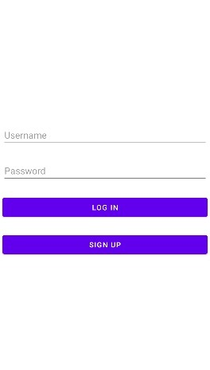

**SIGNUP**

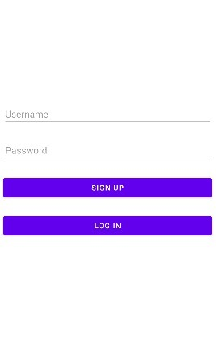

**CAMERA**

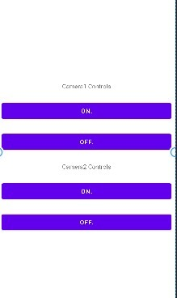

**CAR**

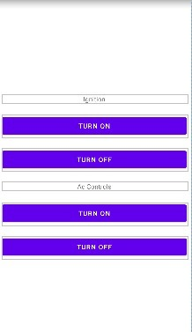

**DASHBOARD**

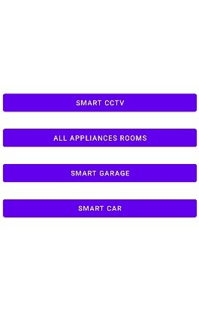

**GARAGE**

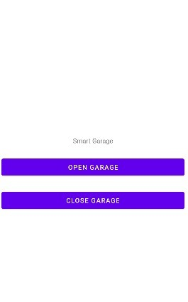

**ROOMS**

